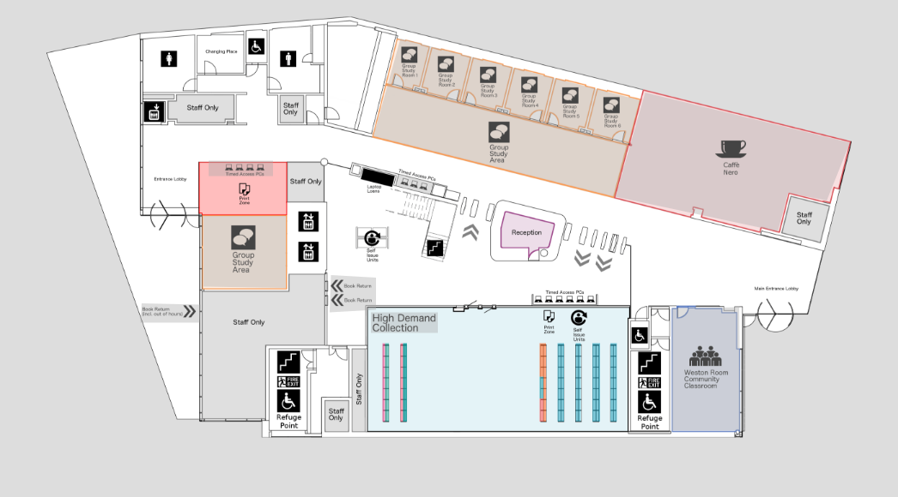

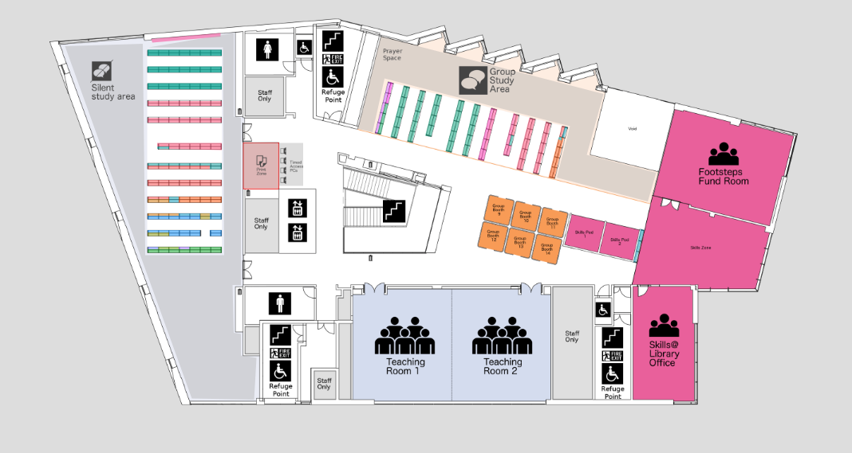

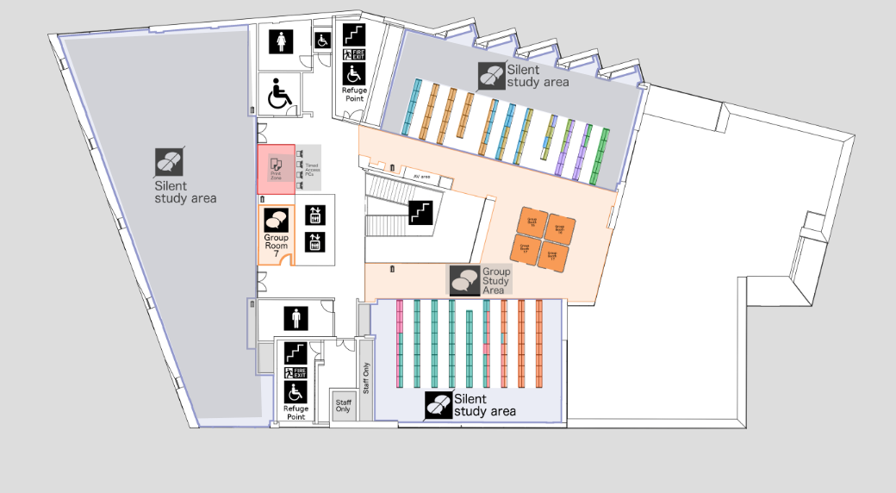

**KEY:**

**Public Area. Hot Food and Drink allowed. Respectful volume level allowed.**

**Group/Collaborative Work Area. Cold food & covered drinks allowed. Conversation allowed.**

**Silent Study. No food, only covered drinks allowed. Silence expected.**

